10 Using a Mixin for Media Queries

Turn on your SASS Watcher

In your main.SCSS file

Create a new @mixin after the @mixin for the theme.

  @mixin mobile {

    @media (max-width: 800px) {

        @content;

    }

  }

But instead of defining that 800px directly in the argument list of the media query, we could also define a variable that would represent that number. That way we can change it around if we needed to when we include it and need to fill in the blanks (so to speak)

Create a new variable called @mobile

Remember that in SASS:



You could place this variable at the top of the page, but since we have a partial file name _variables.scss, we could just place this new instantiation of the variable in there.

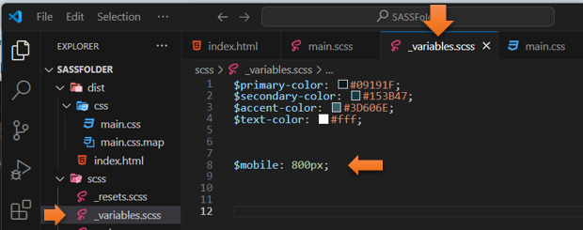

Now back in the main.SCSS file, you can switch out the 800px, with our new variable.

  @mixin mobile {

    @media (max-width: $mobile) {

        @content;

    }

  }

In order for this to work, we need to set the direction for our main div back to (row).

.main {

        @include flexCenter(row);

In .main, right before the closing curly brace, we want to include this new @mobile mixin

        @include mobile {

            flex-direction: column;

        }

        } // I added this final brace so you know where to put it.

The .main code now looks like this

.main {

        @include flexCenter(row);

        padding-top: 5%;

        width: 75%;

        margin: 0 auto;

        #{&}__p   {

            font-weight:map-get($font-weights, bold);

            &:hover {

                color:chocolate;

            }

        }

        @include mobile {

            flex-direction: column;

        }

        }

Go back to index.html to test it and widen and narrow the page to test it. It should show the paragraphs in two rows if the page is wide, and a single column one on top of the other if the page is narrow.

And it works

